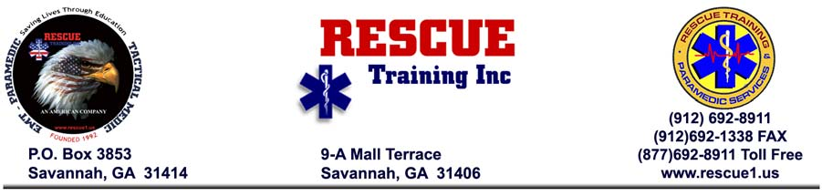

------------------------------------- Tactical Medic Program -----------------------------------

Sensitive Training: "Need-To-Know" Verification

Due to the current world situation we must be ever so cautious as to whom we are providing this training. The tactical training provided by Rescue Training Inc is of a sensitive nature, conducted by law enforcement personnel, and is provided only to those that have a "need-to-know". Precautions are taken to assure that we do not disclose tactical operational information to individuals that could potentially use this information for unlawful purpose.

In order to verify the credibility of those that we train, the applicant must be an EMT and working within the public safety arena (Police. Fire, or EMS), the military, or working within a division of the US Department of Homeland Security.

All applicants must provide verifiable proof of EMT training and public safety employment. This is done by providing a copy of your EMT certification and a letter from your employer, on official company letterhead, verifying this fact and offering the name, rank, and contact phone number of the agency head or authorizing person issuing the letter. Final acceptance into this TEMS Program is contingent upon this verification process.

Again, thank you for selecting our program.

